City of Kramer, Municipal Work Order
ckform-11
Work Order Number (month,year,sequence number) 08-25-07
Name of Project: Lagoon gates
Work Required: Install 2 gates to replace gates at lagoons IAW June inspection.
City Task or Hire out: City Task
Company to complete task
Company contact number
Expected Start Date: September
Expected Finish Date: September
Material Requirements and Description:
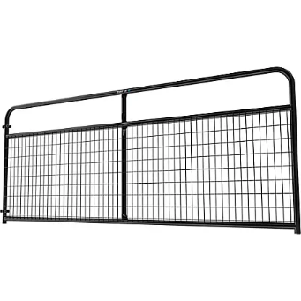
$199.99 each x 2
Total $399.98
Council Determination: Yea Nay
Signatures

