City of Kramer, Municipal Work Order
ckform-11
Work Order Number (month,year,sequence number) 08-25-09
Name of Project:
Work Required: The sump pump works but sticks from age and falling debris. It flooded last week in July. The pump basin is gone. And more importantly, the electrical risk is high to the safety of the structure.
City Task or Hire out: City task and hire out
Company to complete task
Company contact number
Expected Start Date: August
Expected Finish Date: August
Material Requirements and Description:
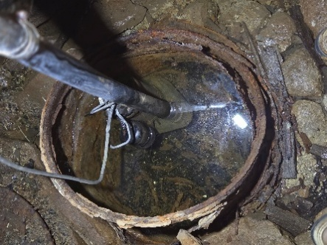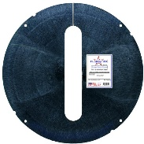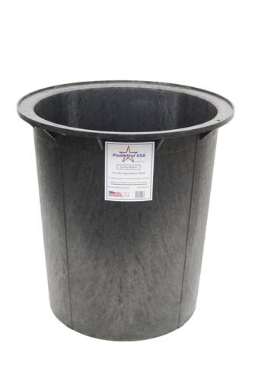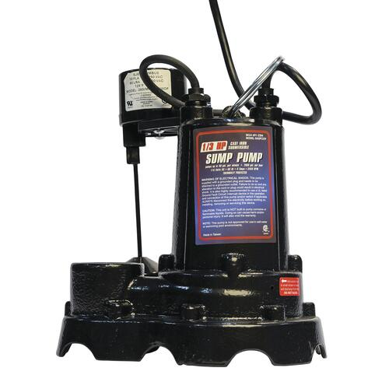
Sump pump at $99.99
Sump pump well and lid at $120.00
Total $219.99
The cost of the electrician is unknown. We can ask for bids or based
on nature of risk get someone in the area an do repair.
Council Determination: Yea Nay
Signatures

