City of Kramer, Municipal Work Order
ckform-11
Work Order Number (month,year,sequence number) 08-25-03
Name of Project: Skating Rink Floor cleaning
Work Required:
The floor of city hall which is used for roller skating is covered with spills from parties and
and other events. The entryway is very bad. The condition of the floor reflects our poor management of the facility. It needs to be mechanically washed, scrubbed and vacuumed.
City Task or Hire out: City Task
Company to complete task
Company contact number
Expected Start Date: Mid August after skating and done within 8 hours of work
Expected Finish Date: Would like to finish before the 1st of September.
Material Requirements and Description:
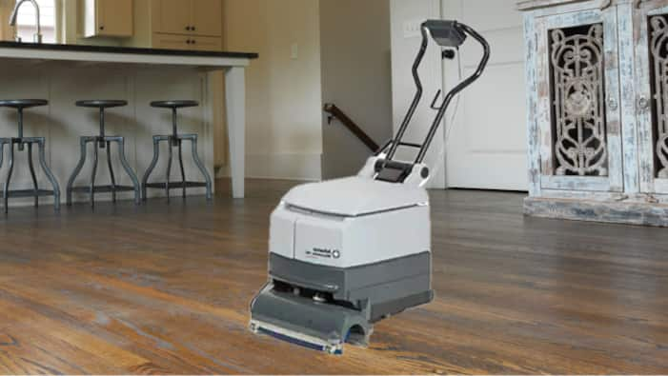
Hard Flooring Cleaners: An easy-to-use automatic scrubber
that deeply cleans concrete, tile, grout, marble and
factory-finished wood floor surfaces. Scrubs and vacuums
in a single pass, in both forward and reverse. Can effectively
scrub 5,500 square feet per hour.
Anticipated costs: $93.00 per day
Council Determination: Yea Nay
Signatures

