City of Kramer, Municipal Work Order
ckform-11

Work Order Number (month,year,sequence number) 8-25-02
Name of Project: Lagoon Dike Mowing
Work Required:
Need to mow the tops of two lagoon dikes. Very large area with heavy grass. Directed by State inspection. Follow-up mowing can be done with zero-turn.
City Task or Hire out: City task
Company to complete task
Company contact number
Expected Start Date: Aug 4 Expected Finish Date: Aug 10
Material Requirements and Description:
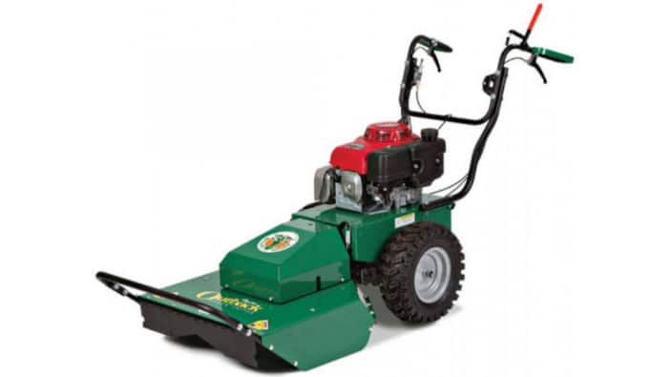
Hydraulic Brush Hog
Category #08 Group #930 - Ideal for rough terrain, hills and high brush. 26" wide,
pivoting deck for easy operation in uneven terrain.
Variable speed and hand controls in forward and reverse.
Anticipated costs
137.00 for day rental. Taxes possible.
Council Determination: Yea Nay Date
Signatures:

