City of Kramer, Municipal Work Order
ckform-11

Work Order Number (month,year,sequence number) 08-25-04
Name of Project: City of Kramer Ct Rd Hwy 15 Sign repair
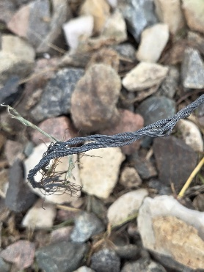
Work Required:
Cables securing the sign have become very loose and one is broken. It needs to be fixed before winter winds push it over.
This preventative maintenance and if not repaired, the city may loose the sign.

City Task or Hire out
Company to complete task
Company contact number
Expected Start Date: August 10
Expected Finish Date: August 11
Material Requirements and Description
Koch Industries Inc Malleable Wire Rope Clip: Current price $1.59 per clip times 4 at $6.36
Koch Industries Inc® Wire Rope Galvanized Cable, Zinc Plated, 7"X7, 3/32" Diameter, Current price $0.59 per foot x 10 feet at $5.90
Anticipated costs
$6.36 clips
$5.90 wire
$12.26 Total and maybe tax
Council Determination Yea Nay Signatures

