City of Kramer, Municipal Work Order
ckform-11
Work Order Number (month,year,sequence number) 08-25-08
Name of Project: City Hall doorknobs and deadbolts
Work Required: Front door lock does not work and does not have a doorknob lock, north door will not close tightly, only south door is good. Neither north or south doors have doorknob lock.
City Task or Hire out: City Task
Company to complete task
Company contact number
Expected Start Date: September
Expected Finish Date: September
Material Requirements and Description:
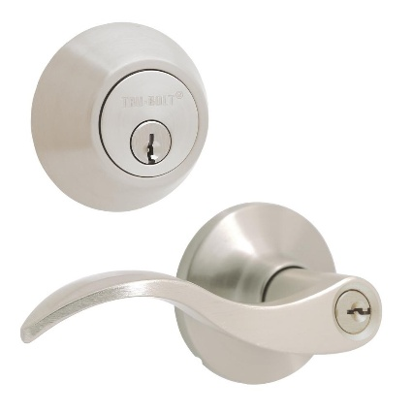
$28.45 each x 3 same key
Total $85.35
Council Determination: Yea Nay
Signatures

